Faith Formation Files: Vol. 1, Issue 16 January 27, 2019
One of my New Year’s resolutions was to help parishioners identify their gifts and provide opportunities where they could share them. I would like to take the opportunity this week to do that. Some of you may have heard at Faith Formation class how I would like to institute “Service Saturdays.” I envision having one Saturday a month where a group of people with similar gifts come together to do something for others. Those who knit, crochet, or sew could spend a few hours making hats, gloves, lap robes, etc. which would then be donated to schools, nursing homes, the homeless, etc. Those with green thumbs could beautify the church grounds or a home bound parishioner’s yard. Those with carpentry skills could do some minor repairs for a needy family. Those with vehicle maintenance skills could run a mini repair shop in the church parking lot performing tasks such as changing headlights or wipers, refilling fluids, and confirming a need for bigger repairs to be done by a certified mechanic. Those who love to cook could prepare some freezer meals to be distributed to new parents, senior citizens, or other home bound friends. We all have so many gifts that God has given us. We just need to find a way to share them with others.

Please take a few minutes to identify your skills and interests. Return your survey to the offertory basket or parish office. I will compile responses and organize some service project days. If you have other ideas for how we can share and support each other and God’s people, please let me know. You can call the parish office, drop me an email, or add notes on your survey and return it to me. Thank you for your participation.

Blessings,
Julie Gould
This Week: faithformation@ctknsf.org
- Sunday, Jan. 27, 4-6 pm at Fellowship Hall: GIFT, we begin with a potluck
- Monday, Jan. 28, 7 pm at Fellowship Hall: Adult Enrichment Class
- - - - - - - - - - - - - - - - - - - - - - - - - - - - - - - - - - - - - - - - - - -
Please check any and all interests, talents, or skills.
___ word processing ___ social media ___ using the Internet
___ cooking/baking ___ gardening/green thumb ___ landscaping/yardwork
___ carpentry ___ basic home repair ___ automotive
___ card making ___ scrapbooking ___ crafting
___ knit/crochet ___ sewing/quilting ___ painting
___ time mgmt. ___ money mgmt. ___ organization
___ couponing ___ reading ___ writing
___ camping ___ fishing ___ bicycling
___ praying ___ sports: please specify ___ computer skills: specify
___ walking/running ______________________ ____________________
Please list any other skills or talents you have. What ideas do you have for sharing them?
____________________________________________________________________________________
____________________________________________________________________________________
Name____________________________ phone_________________ email_______________________
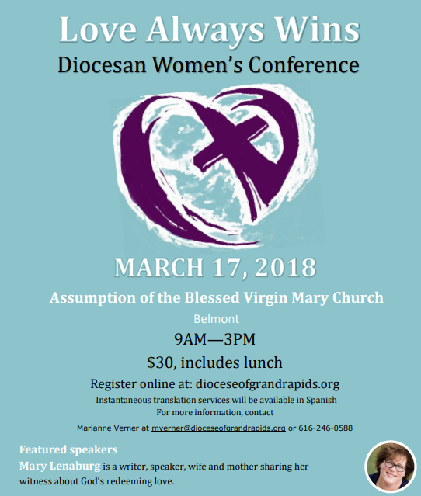

Date & time: March 17, 2018
9 a.m. to 3 p.m.
Cost: $30 pp, includes morning hospitality and lunch (after March 12, registration fee increases to $35)
Location:
Assumption of the Blessed Virgin Mary Church
6390 Belmont Ave. NE
Belmont, MI 49306

- - - - - - - - - - - - - - - - - - - - - - - - - - - - - - - - - - - - - - - - - - -
If you have any other ideas for Service Saturday projects, would be willing to organize a day/ event, have leads for materials, supplies, or other funding, or any other advice, suggestions, or questions, please let me know. Thank you!

