Faith Formation Files: Vol. 2, Issue 2 October 6, 2019
When I was 22 years old, my best friend and I went to England. We planned to travel, stay with friends, and work while there for about 3 months. It was an amazing experience and one I certainly couldn’t contain to a single page of text. But today I’d like to share with you one particular adventure of this trip of a lifetime.
Just because we could, my friend and I took a ferry from Portsmouth, England to Le Havre, France with the intention of travelling on to Paris to see the sights. We made our way to the docks. We bought our tickets and boarded the ferry. We began our trip across the English Channel, a distance to be covered in just shy of four hours. Now because we did almost everything on the trip at the “economy” level, we did not have access to private cabins, nor even the adjustable recliners in which to sit back and relax. In fact, what were available to us, for the price we paid, were hard plastic chairs. And they weren’t even individual or mobile. No, there were banks of 6-8 chairs attached to each other and then bolted to the floor. So if you wanted any personal space or if you wanted to rest, you had to find a spot on the floor. You were welcome to sit against the wall or even lie down, but that was it. Since we opted for neither of those options, we decided to explore the ship. Lo and behold, we discovered “Cinema at Sea.” There was a darkened room with comfortable seating. An American comedy was being shown and there was no extra cost for this luxury. Needless to say, we thought we’d hit the lottery! Even better, we befriended some guys who were also at the movie. They spoke English and French, were familiar with the port city where we’d be docking, and they were willing to help us get to a hotel so we could go to Paris the next day.
Well, for the sake of getting to the point of this story, let’s fast-forward to the end of the evening. We had our room and had gone out with the guys to experience the night life of Le Havre. We had taken a couple different taxis, had walked between 2 or 3 establishments, the sun had long gone down, and we had indulged in enough adult beverages that our judgment was at less than peak performance. In spite of the great fun we were having, we decided that we needed to head back to the hotel to try to get some rest before catching a train to head into the city in the morning. The guys decided they weren’t ready to head back yet. In fact, they were upset enough that they pretty much “ditched” us leaving us to find our way back ourselves.
Neither my traveling companion nor I spoke French. We were in a town we’d never been to. We had ventured all around and throughout the city paying absolutely NO attention to where we were going or where we had been. It was about 3 am and neither of us was in any condition to save ourselves, but we were all we had.
We stood on that dark and lonely street for quite a few minutes trying to get our bearings and to see if we could come up with some kind of solution to our situation. Then, far, far off in the distance I heard some church bells ringing. I recalled that our hotel (we didn’t even know the name of it!) was right by a cathedral. Perhaps because we had no other ideas, we started to walk toward the sound of the bells. Every 15 minutes we got a chance to reorient ourselves towards the tolling and to be rewarded by the increased volume telling us that we were getting closer. Eventually, we did end up finding our room for the night, but it was only by the grace of God. (Do you know how many churches are in those Old World cities?!? How was it that there was only one that rang out as if calling us home?)
So what’s the point of this whole tale? It’s important, imperative even, to know your destination! Whether you refer to a paper map, print off directions, or have GPS directing you turn-by-turn, you must know where you are headed in order to get there. So it is with our lives in eternity. If we want to end up in the right place, then we need to know where we’re going. We need to recognize Heaven as our ultimate destination. To get there we need to follow the directions provided by God. We need to pay attention to the landmarks, follow the traffic signs, and trust the detours. And when all else fails, move towards the call of God. Sometimes His voice sounds like tolling church bells.
As we begin our new year of Faith Formation, our first topic focuses on Heaven as our Destiny. Please feel free to join us on Sunday in Fellowship Hall right after the 11 am Mass. You are always welcome to join us!
Blessings,
Julie Gould
faithformation@ctknsf.org
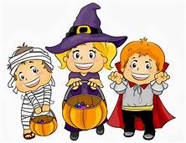
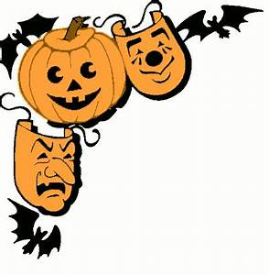

Trunk or Treat
Thursday, October 31st
6-8 pm in Fellowship Hall

Our parish, along with our Knights of Columbus, is hosting Trunk or Treat, a fun, safe way for kids to celebrate Halloween.
We will have hot dogs, chips, donuts, cider, and of course, candy!
We are looking for people to help donate any of the above items. Candy can be left in the box in the narthex of either church. Foods needing refrigeration should be dropped off at the parish office during business hours so it can be properly maintained.
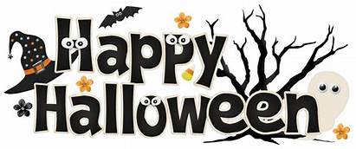
We would also appreciate folks to come distribute candy at this event. You can either bring your own or use what gets donated. This provides a spot for those people who enjoy seeing the trick-or-treaters but don’t normally have kids stop at their house. Please contact the church at 231-937-5757 or talk to Rick Hall to let him know you can help pass out treats.
Thank you and

