Faith Formation Files: Vol. 2, Issue 12 December 22, 2019
This Advent has been challenging for me. It seems like I’d barely gotten my game plan together and was ready to start it, and here we are at week 4 already! I had decided that I was going to pick one of the Cardinal Virtues to focus on and better implement in my life. I chose fortitude. I wanted to stay the course, to keep my nose to the grindstone, to keep on keeping on. And in hindsight, I think I can claim victory. I have had to work hard this month to prepare myself for Christmas. I’ve been busy at work with Faith Formation classes, the Service Saturday event, participating in Howard City’s Christmas Parade, working with groups behind the scenes to make sure local families have food and gifts for their loved ones, among all the other things that go on in life this time of year. In addition to all these, I have worked to keep up with parenting and other family obligations. I’m not necessarily sure that my fortitude was a proactive decision on my part as much as it was a simple response to “life goes on” and I might as well try to keep up. (Imagine me holding one end of a rope tied to a wild dog sled team just let loose to run the Iditarod. That’s often how I felt; pulled along without any control or say in the matter.) So I’m not sure I can claim victory after all. Virtues are supposed to be purposeful and habitual. Mine was more reactive and complementary to survival.
But one thing that did really click this Advent for me was how I perceived the idea of “the birth of Christ.” I know that the first Christmas that happened over 2,000 years ago, did really, really happen. Joseph and Mary traveled to Bethlehem. Jesus was born in a stable (or some type of humble accommodations) and laid in a manger. Shepherds were among the first to hear of His arrival and to visit Him. So, I wonder, how do we prepare to celebrate the birth of Christ? It’s not like he can be re-born. And we don’t celebrate Christmas as “just” His birthday, an annual recognition of His birth. So I thought about it. I questioned it. I tried to rationalize it. And I prayed about it. And what I came up with is that maybe we are not preparing for Jesus to be born again, as a baby to weary travelers far from home in a lowly lodging. Perhaps what is being born is the spirit of Christ within us? Maybe this season is a time to reestablish our relationship with Christ? Maybe we are to use this opportunity to rekindle the fire and intensity of our love for God? Maybe we’re supposed to reprioritize what gets our attention, out time, our effort, and our commitment?
If you have viewed Advent as just a liturgical season, the four weeks prior to Christmas when we hear readings about Noah, John the Baptist, King David and the prophet Nathan, the angel Gabriel, Elizabeth, and the Holy Family of Joseph, Mary, and Jesus, maybe you’ve missed a great opportunity. We hear the directions to prepare ourselves, to be ready, to always be expecting the coming of the Lord, but are you really doing that? I know that I have not. But I have been given the gift of having my eyes opened to the possibility of what this season is really about. And so I’m giving that gift back to God for Christmas. I’m going to try hard to make sure that I am constantly growing in my faith. I’m going to attempt to ensure that the burning within me is fanned so that my light can spread. I’m going to make an effort to order my life so that God holds His rightful place in my heart. This is probably better than myrrh anyway.
There are no other Faith Formation classes for the 2019 calendar year. Please take the time to be with your families, to celebrate the real reason for the season, to nurture your domestic church, and to grow your relationship with our Lord. We will reconvene on Sunday, January 5th. Our topic for the month will be the Two Great Commandments: “You shall love the Lord, your God, with all your heart, with all your soul, and with all your mind. This is the greatest and the first commandment. The second is like it: You shall love your neighbor as yourself. The whole law and the prophets depend on these two commandments” (Matthew 22:37-40). We will also take a closer look at the first 3 of the Ten Commandments. I hope that as you consider your New Year’s resolutions you will consider attending our Faith Formation classes as part of how you choose to better yourself.
I wish you and your family the very best Christmas yet! May all your wishes come true. And a very happy New Year to you, as well. Here’s to 2020 being an exalted year.

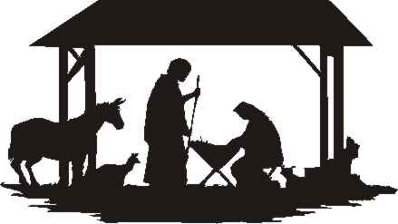
Blessings,
Julie Gould
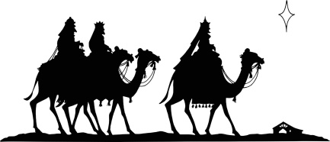
faithformation@ctknsf.org

