Faith Formation Files: Vol. 2, Issue 17 February 2, 2020
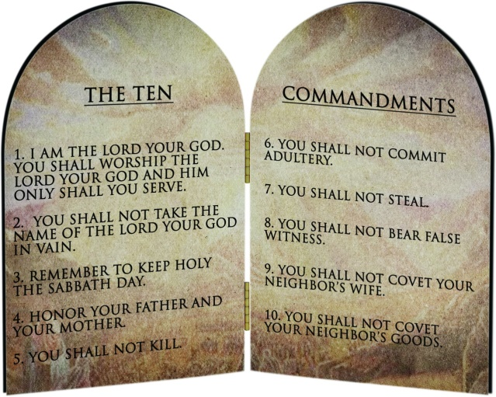
This month at Faith Formation we will be learning about and discussing the 5th through the 10th Commandments. The 5th Commandment, You shall not kill, seems so very straight-forward that one wonders how else it could be considered or how difficult it could be to obey? But I tell you, there are multiple ways that this commandment can be broken, and I personally know people who have done so in at least four of those ways.
Most clearly, to commit murder is to kill. I don’t know anyone who has actually done this, I’m glad to say. But considering the state of our world, I wouldn’t say that being removed from it by just one or two degrees is very possible. Unfortunately, I do know at least two people who have been murdered. Taking another’s life is incomprehensible.
Another way this commandment can be broken is by having or encouraging someone to have an abortion. The Catechism articulates the belief in the sanctity of all human life from conception to natural death. This is reflected in paragraph 2273, as well as the preceding and subsequent paragraphs. In 2270 it says, “Human life must be respected and protected absolutely from the moment of conception.” I know a woman who at the age of about 18 years became pregnant before marriage. The father was of another race. A pre-marital, bi-racial pregnancy in the late 1980’s was an unfathomable situation. Feeling as though they had no other options, they sought an abortion. Whether the trauma that follows such a decision caused it or if there were other contributing factors, the couple eventually broke up. She did go on to marry and have 12 children! I presume she was attempting to “make up” for the loss of her first child’s life and will always grieve her decision.
A third way the 5th Commandment can be broken is by committing euthanasia. “Direct euthanasia consists in putting an end to the lives of handicapped, sick, or dying persons. It is morally unacceptable.” (CCC, 2277) Even though it is hard to see our loved ones suffer, it is beyond our human privilege to presume we know better than God regarding when someone is no longer “worthy” of life or when they have lived “long enough.” I have a friend whose grandfather was diagnosed with a terminal disease. I was young enough not to remember all the details exactly, but I recall that he was no longer able to move his arms. His wife, who was living with Alzheimer’s, was still living with him. Their daughter lived next door and they were well taken care of by her. Anyway, one day we heard that he had died of a self-inflicted gunshot wound. But the man had lost the use of his arms… I don’t know the specifics for sure, but I’m sure that the wife thought she was doing the very best for her husband in whatever way she assisted.
Another way people can break the 5th Commandment is by committing suicide. CCC 2280 says, “We are stewards, not owners, of the life God has entrusted to us. It is not ours to dispose of.” The church is understanding of those who suffer from mental illness or are suffering other distress. For them we pray. My brother-in-law committed suicide about 4 ½ years ago. He was plagued with feelings of inferiority, unworthiness, and depression. Ultimately, he must have believed that his family would be better off without him. I don’t know what else we could have done to support him in his life, but I know that he is dearly missed. His wife and daughter would much rather deal with his anxiety and feelings of mediocrity yet still have him to hug than how things turned out.
Have you ever considered that it is yet another way to break this commandment when you “kill” someone’s spirit? Have your words or actions ever been so vindictive or hurtful that you have contributed to someone’s feelings of insignificance or self-loathing? Have you encouraged or supported someone who was doing this to another? Have you delighted in someone else’s failure or pain? Parents, spouses, siblings, and co-workers can say and do awful things to each other in an attempt to tear the other down. I bet we all know someone, or are guilty ourselves, who has done this type of thing.
There are yet other examples of how this 5th Commandment can be broken. Scandal is covered in CCC 2284- 2287 but is summed up in 2326, “Scandal is a grave offense when by deed or omission it deliberately leads others to sin gravely.” Also covered in the Catechism is the respect of health. We are called to take good care of our bodies, but not to invest so much that it becomes an obsession. We are told to make sure the health of others is protected or given assistance in attainment of food, clothing, housing, education, health care, education and employment. We are also to not abuse ourselves through the use of/excessiveness of food, alcohol, tobacco, and medicine/drugs. Within the dissertation of the 5th Commandment the Catechism even clarifies the church’s standing on a number of topics including but not limited to embryo production and selection, chromosomic manipulation, what is commonly known as Hospice care, reckless actions that pay no heed to harm to self or others, basic scientific research as well as applied research, organ transplants (donation after natural death is noble and meritorious!), respect for the dead, anger, and war. Check out the entire text in the Catechism of the Catholic Church Part three, Section two, Article five, paragraphs 2258-2330.
As you can see, this commandment like so many others is multi-faceted and so much deeper than just surface level. Come to Faith Formation in Fellowship Hall after the 11 am Mass to join in our learning and discussion of this and the remaining 5 Commandments.

Blessings,
Julie Gould
faithformation@ctknsf.org

**Please note that instead of having Faith Formation class next Sunday, February 9th, we will be hosting training on how to use our new AEDs. The First Communion class will still meet from 4-6 pm. We will also have our other regularly scheduled classes on February 16th- A Family of Faith Potluck & Follow-Up meeting and February 23rd- GIFT.**

